

Product design document

Assignment 1



August 21, 2015

Team HeartSoft

**Hyunwook Kim - s11076744**

**Krishneel Singh - s11097514**

**Sanjay Sharma – s11108277**

**Archana Kiran – s11109012**

**Robert Makasi – s11061978**

Contents

**Context Level Diagram** 4

**Data Flow Diagram** 5

(Level 0) 5

(Level 1) 6

Register Patient 6

Register Doctor 7

Update Medical History 8

View Medical History 8

Search Patient 9

Search Doctor Account 9

**Use Case Diagram** 10

(Doctor User Case) 10

(System Admin Use Case) 10

(Patient Use Case) 11

**Sequence Diagrams** 12

(Login) 12

(Add Account) 13

(Data Search) 13

(Medical History Creation) 14

(Update Patient Medical Data) 14

**Class Diagram** 15

**Entity Relationship Diagram** 16

**Activity Diagram** 17

(Login) 17

(Patient) 18

(Add Account) 19

(Doctor Registration) 20

(Patient Medical Record Update) 21

**State Chart** 22

(System Administrator Authentication) 22

(Search and registering Doctor) 23

(Patient visit clinic) 24

(Patient Authentication) 25

(Patient view medical history) 26

(Doctor Authentication) 27

(Search, View and Update patient) 28

# **Context Level Diagram**



# **Data Flow Diagram**

## (Level 0)



## (Level 1)

## Register Patient



## Register Doctor



## Update Medical History



## View Medical History



## Search Patient



Search Doctor Account  


## **Use Case Diagram**

## (Doctor User Case)



## (System Admin Use Case)



## (Patient Use Case)



## **Sequence Diagrams**

## (Login)



(Add Account)

## (Data Search)



## (Medical History Creation)



## (Update Patient Medical Data)



## **Class Diagram**

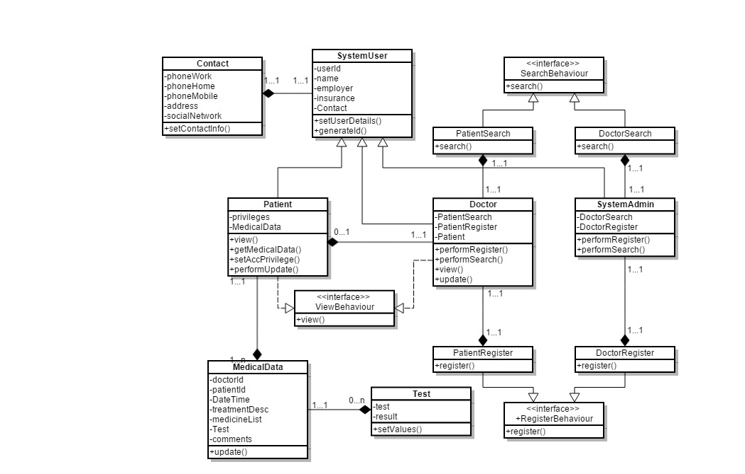

## **Entity Relationship Diagram**



## **Activity Diagram**

## (Login)



## (Patient)



## (Add Account)



## (Doctor Registration)



## (Patient Medical Record Update)



## **State Chart**

## (System Administrator Authentication)



## (Search and registering Doctor)



## (Patient visit clinic)



## (Patient Authentication)



## (Patient view medical history)



## (Doctor Authentication)



## (Search, View and Update patient)

